Blair Minton Assignment 14

1 & 2:
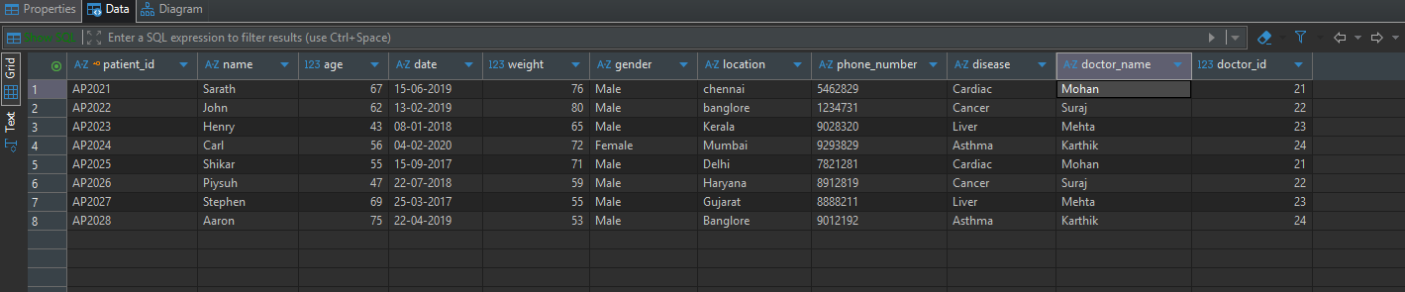
CREATE TABLE patients (
patient_id integer primary key,
name varchar (255),
age integer,
date varchar (255),
weight decimal (10,2),
gender varchar (255),
location varchar (255),
phone_number varchar (255),
disease varchar (255),
doctor_name varchar (255),
doctor_id integer
);
3:

SELECT count (patient_id) as total_patients
from patients;

4:
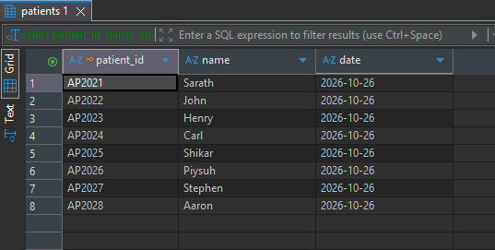
select patient_id, name, current_date as date
from patients
5:

select name as OriginalName,
date as NewestPatient,
UPPER(name) as CapitalizedText
from patients
order by date desc;

6:

select length(name) as string_length,
name as PateintName
from patients;

7:
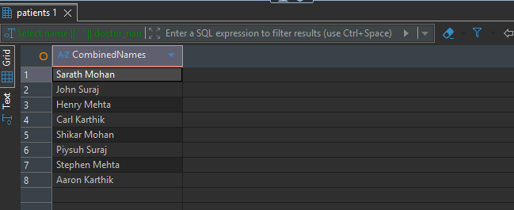
Select name || ' ' || doctor_name as CombinedNames
from patients;

8:
select date, SUBSTR(date, 7, 4 ) as PatientYear
from patients;
9:
Select doctor_name,
count(doctor_name) as DoctorCount
from patients
group by doctor_name

